**Author:** Kristina Krtalić

**Title:** Dance with Ally

**Purpose of the challenge**  
- learn to connect micro:bit with Scratch via Bluetooth

- understand how to use the Scratch micro:bit extension

- use micro:bit buttons to interact with Scratch projects

- create interactive games with micro:bit

- develop problem-solving and logical thinking skills

- enhance creativity through coding

**Description of the challenge**

Create a program that will enable simple dance a sprite in Scratch with a micro:bit.

Educational goals:

Coding and Programming Logic:

* students will use Scratch blocks to write event-driven programs that respond to inputs from the micro:bit
* students will understand and apply fundamental programming concepts such as loops, decision, conditionals and variables
* students will build fluency with block-based programming to control digital and physical outputs

Computational Thinking:

* students will decompose problems into smaller parts and design solutions step by step using Scratch
* students will use sensor data (e.g., buttons, shake) from the micro:bit to control sprites or animations
* students will develop and test algorithms to solve specific challenges (e.g., making the sprite dance when the micro:bit is tilted).

Problem Solving and Debugging:

* students will engage in iterative design by testing, identifying bugs, and refining their Scratch code and micro:bit interactions
* students will troubleshoot real-time errors involving both software (Scratch scripts) and hardware (micro:bit connection or inputs)
* students will document and reflect on changes made during debugging.

Creativity and Design Thinking:

* students will create original animations, games, or stories in Scratch that integrate micro:bit inputs as interactive elements
* students will express themselves artistically by choreographing sprite movements or designing interactive scenes
* students will follow the design process: empathize, ideate, prototype, and test

Collaboration and Communication:

* students will work in pairs or small teams to plan, code, and present interactive projects
* students will explain their design choices and code logic to peers or a broader audience

By connecting Scratch and micro:bit, students gain a comprehensive learning experience that integrates digital and physical computing, enhances problem-solving abilities, and encourages creative exploration.

**Target audience**   
Primary School students (6 to 12 years)

Lower Secondary School students (12 to 16 years)

**Experience**   
Intermediate - Some basic coding knowledge is recommended; participants should be familiar with fundamental programming concepts.

**Duration**   
60 minutes

**Recommended tool:**   
computer

Scratch (https://scratch.mit.edu/)

Scratch link (https://scratch.mit.edu/download/scratch-link)

Scratch micro:bit (https://scratch.mit.edu/microbit)

micro:bit

sprite Ally (https://codeweek-s3.s3-eu-west-1.amazonaws.com/chatbot/ally.png)

**Instructions**  
1. Start Scratch.

2. Create an account in Scratch (if you don't have one).

3. Start creating a new project, add a sprite, add a background, determine the initial position of the sprite when starting the program.

, Picture

4. Add a group of micro:bit scripts from the Scratch programming language extension.

, Picture

5. Connect the micro:bit to the computer, turn on Bluetooth on the computer (if it is not turned on).

6. Install and run Scratch link <https://scratch.mit.edu/download/scratch-link>, download the micro:bit HEX file and save (copy) it to the micro:bit <https://scratch.mit.edu/microbit.>

, Picture

7. The micro:bit extension, find a device near the computer by clicking on the orange button in the micro:bit extension.

8. Search and find devices.

, Picture

9. Create a program with blocks that will enable a sprite dance to selected music (with the start sound block)) that moves when we shake the micro:bit. The dance consists of only two commands: slide on the x-axis left and right. Save the project to your computer.

After creating the program according to the instructions, students can add their own blocks, determine the sprite's controls by pressing the A and/or B button on the micro:bit, change the sprite`s appearance, change/add movements,...

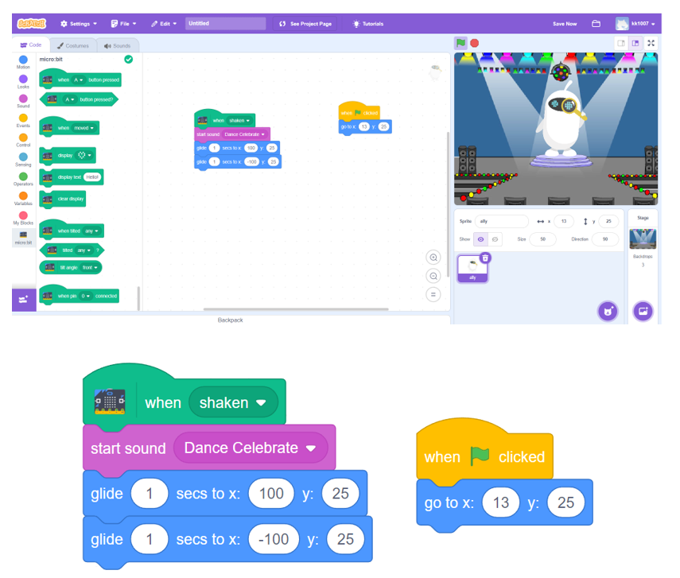

**Examples:**

Connecting a micro:bit with Scratch to control a dancing sprite is a great way to explore interactive programming. This concept can be extended to various real-life applications and creative projects, such as:

1. interactive dance & fitness programs

- use the micro:bit’s accelerometer to track movement and create fitness games

- make a dance learning tool where the sprite follows real-life dance moves

2. gesture-based animation & gaming

- control Scratch characters with hand gestures or tilt movements

- develop simple motion-controlled games, like jumping or dodging obstacles

<https://microbit.org/projects/make-it-code-it/step-counter/>

