Author: Chouliara Theodora
Title: Train it like Fei-Fei Li – Giving Vision to Computers!
Purpose of the challenge
- To learn the basics of Machine Learning and image recognition.
- To train a computer to distinguish between different images (e.g., dog vs. cat, dolls vs. teddy bears).
- To explore how AI and Machine Learning are used in real life.
- To be inspired by Fei-Fei Li’s contributions to AI and image recognition.
- To encourage girls to engage in coding and STEM careers.

Description of the challenge
Train an AI model like Fei-Fei Li! Use Teachable Machine to teach a computer to recognize images and explore the power of Machine Learning while breaking gender stereotypes in tech.

Target audience
Primary School students (6 to 12 years)

Experience
Beginner - No prior coding experience required; suitable for complete beginners.

Duration
60 minutes

Recommended tool:
Teachable Machine (accessible via web browser)
Computer or tablet with a camera
Internet connection (for training the AI model)
Toys and classroom objects (e.g., dolls, teddy bears) for training the AI model
Projector or screen (optional, for classroom demonstrations))

Instructions
Step 1: Introduction to Machine Learning & Fei-Fei Li
Explain Machine Learning:
Computers can learn to recognize images, just like humans. Machine Learning helps
computers "see" objects by analyzing examples.
Introduce Fei-Fei Li:
Fei-Fei Li is a leading scientist in AI and Computer Vision. She developed ImageNet,
a huge dataset that taught computers to recognize images. Just like Fei-Fei Li helped
computers see, boys and girls can teach a computer to recognize objects too!

Step 2: Set Up Teachable Machine
Go to Teachable Machine (https://teachablemachine.withgoogle.com/train)
Choose "Image Project" to train the computer to recognize images.
Click on "Standard Image Model".

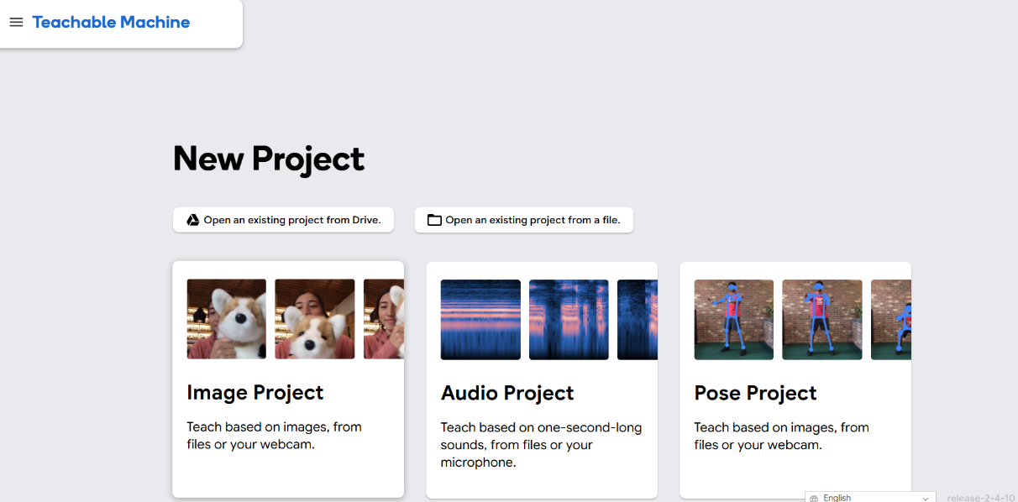
Step 3: Choose Categories for Training
Decide what categories you want the computer to recognize. You can create
categories based on classroom objects (e.g., blocks, teddy bears, dolls, etc.).
Example categories:
Dolls and Teddy bears

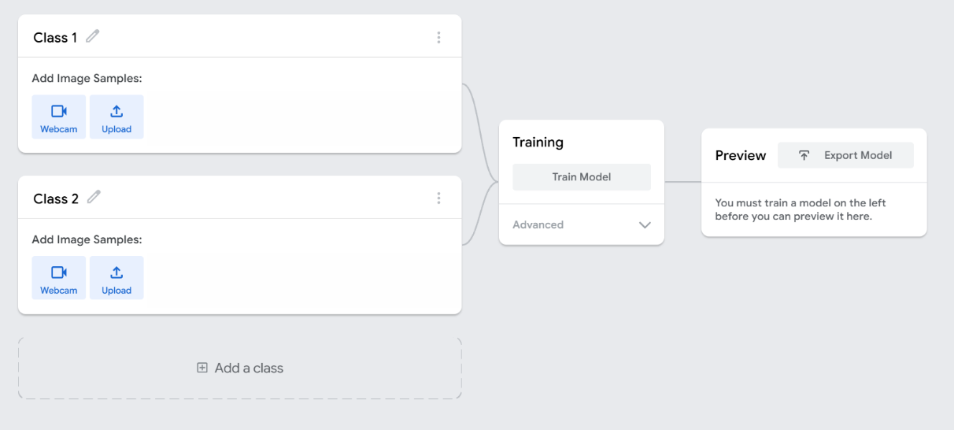

Step 4: Collect Training Images
Create two categories: Dolls and Teddy Bears.
Option 1: Use real objects
Show a doll in front of the camera and take pictures for the "Dolls" category.
Do the same for a teddy bear for the "Teddy Bears" category.
Option 2: Find images online
Search for pictures of dolls and teddy bears on Google.
Save the images in two separate folders ("Dolls" and "Teddy Bears").
Upload the images from each folder to the Teachable Machine for training.

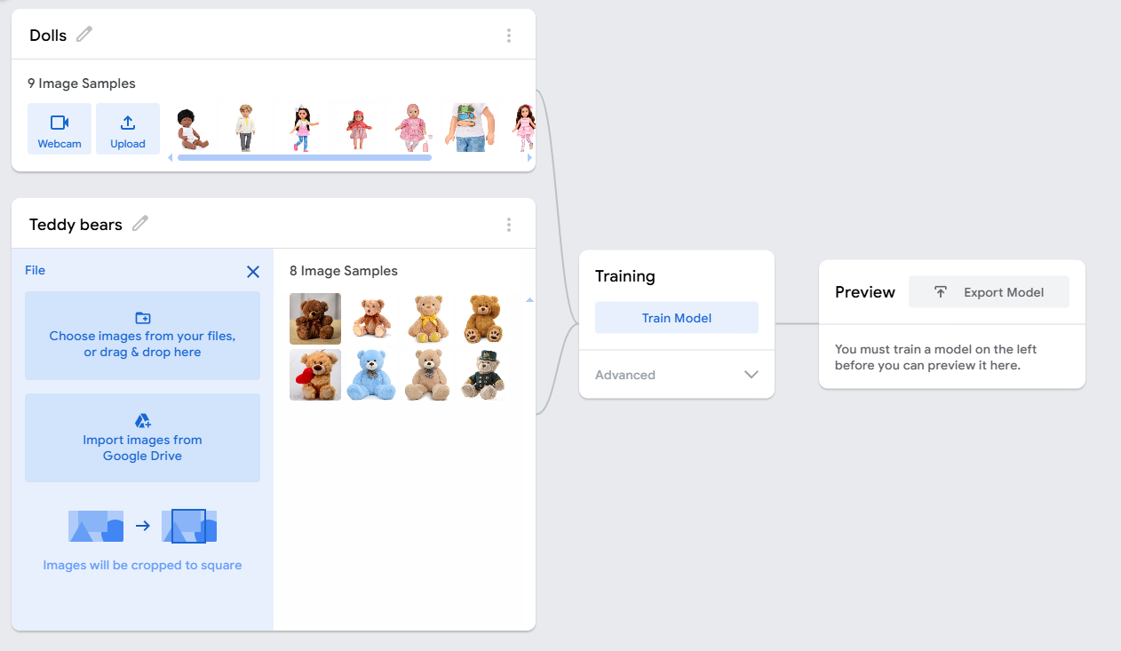

Step 5: Train the AI Model
After capturing enough images, click "Train Model".
Wait for the model to learn from the images.

Step 6: Test the Model
Once the model is trained, click "Test Model" to see how well it recognizes new
images. Test the AI by showing the computer new objects that were not part of the
training images (e.g., show a toy that wasn’t used for training). See how well the
model recognizes it and categorizes it correctly.
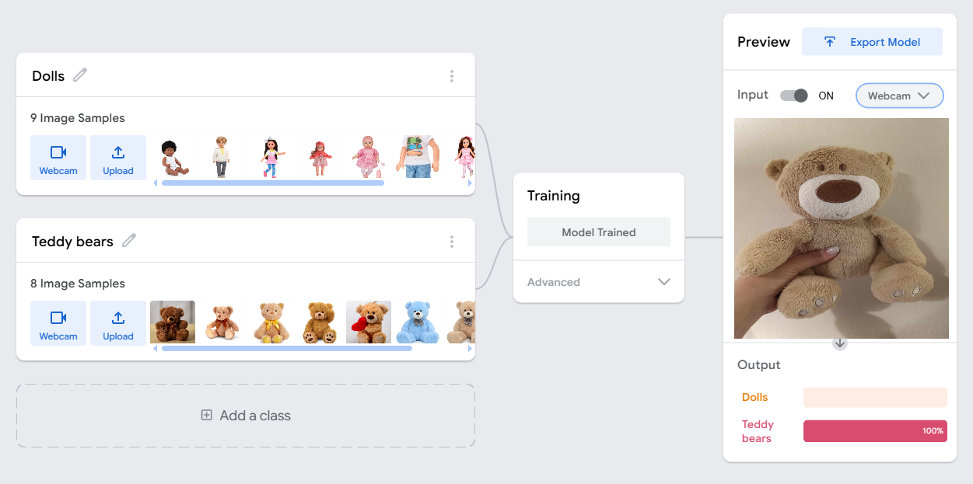
Step 7: Evaluate the Model
Discuss with the students:
Did the model recognize the objects correctly?
Were there any mistakes? What could be improved?
What happens if you train it with more pictures?

Step 8: Save and Share the Model
Once you are happy with the model’s accuracy, click "Export Model" to save your
project. You can share the model with other classes or on the Teachable Machine
website by clicking "Share".

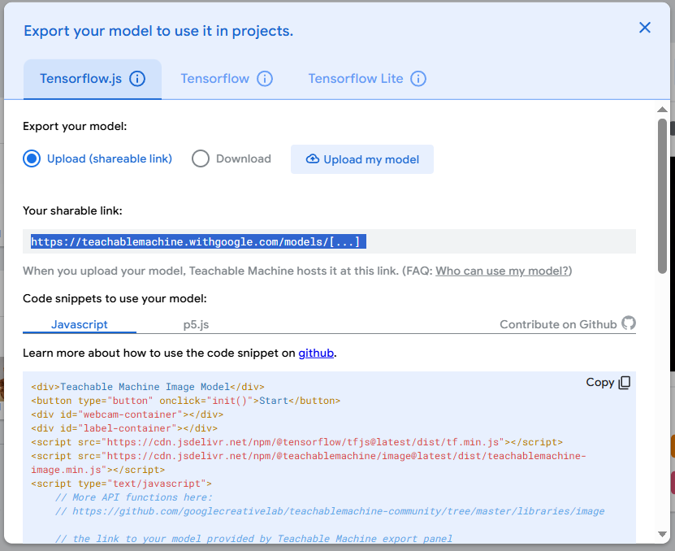

The model we made above can be found here:
https://teachablemachine.withgoogle.com/models/hRNy1ZPlQ/

Examples:
• AI in Retail & Shopping:
Some stores use AI-powered cameras to recognize products and track inventory.
Similar technology helps self-checkout systems recognize items without barcodes.
AI & Assistive Technology

• AI can identify objects to help visually impaired individuals navigate the world.
Smart cameras can describe what they "see" to assist users in real time.



